
ST ANDREW’S JUNIOR COLLEGE
Preliminary Examinations
Higher 2

H2 Geography 9173/01
Paper 1 22 August 2024
INSERT 3 hours

READ THESE INSTRUCTIONS FIRST

This insert contains all the Resources referred to in the questions.

This document consists of 6 printed pages.

[Turn over
Resource 1 for Question 1

Crude oil reserves in billion barrels (Gbbl) in 2019

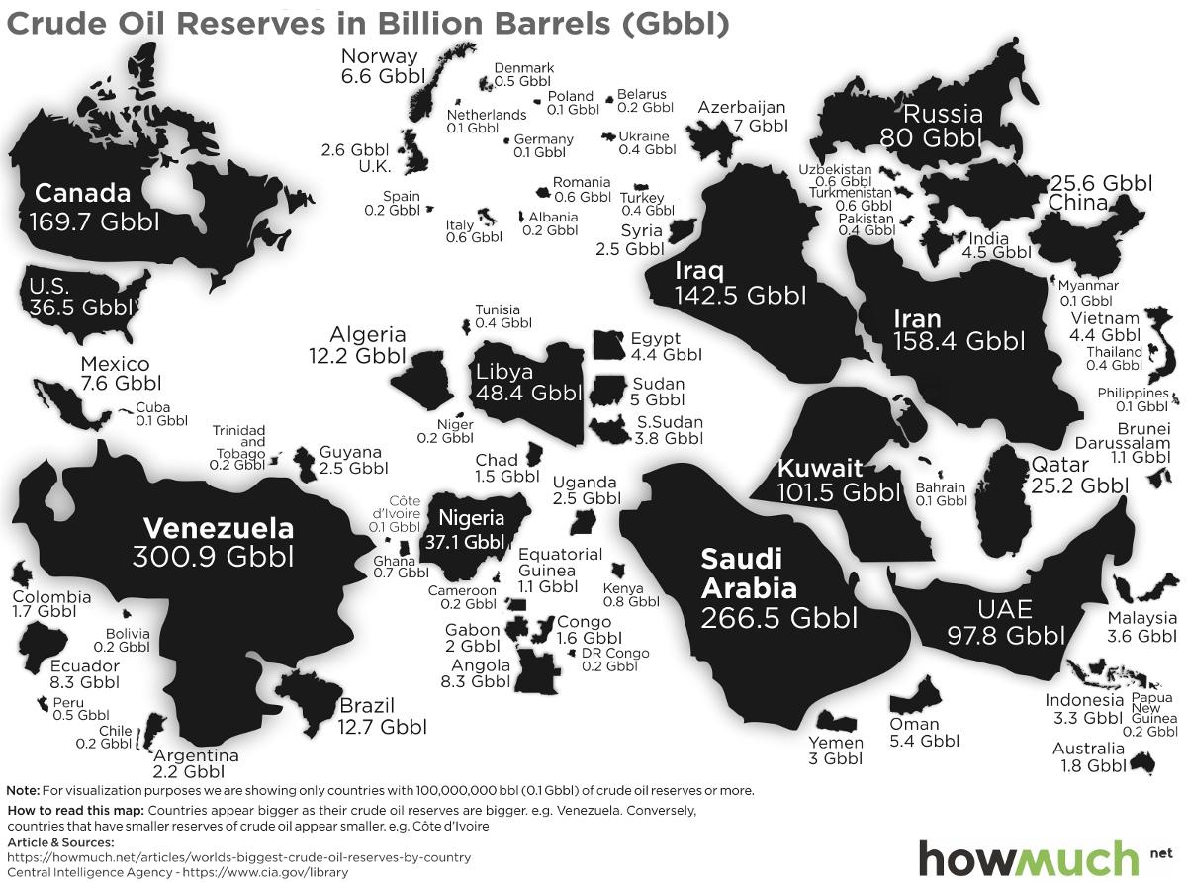

Resource 2A for Question 1  Location of the proposed Luang Prabang dam along the Mekong River Delta | Resource 2B for Question 1  Land use and land cover along the Mekong River Delta
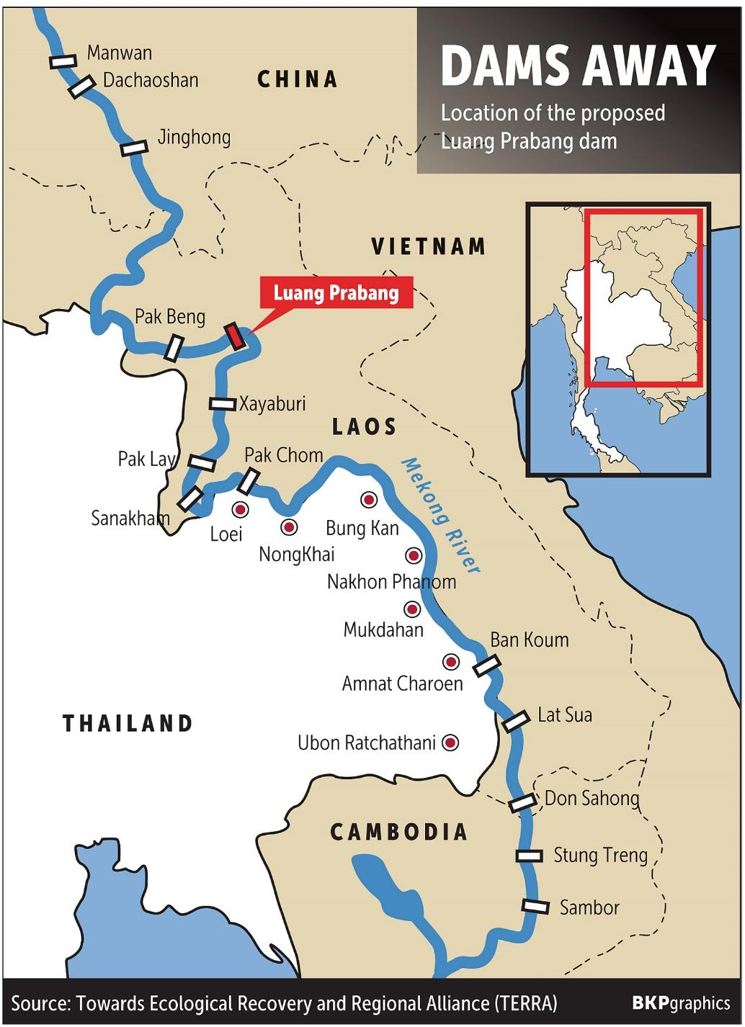  Luang Prabang, a UNESCO World Heritage site, is an outstanding example of the fusion of traditional architecture and Lao urban structures with those built by the European colonial authorities in the 19th and 20th centuries. Its unique, remarkably well-preserved townscape illustrates a key stage in the blending of these two distinct cultural traditions. | 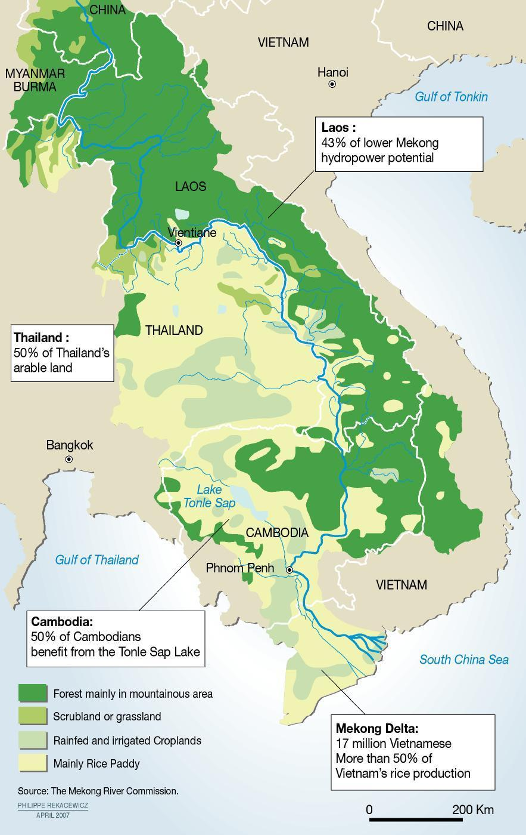
[Turn over

Resource 3 for Question 2

Neutral phase of the El Niño Southern Oscillation (ENSO) along the equatorial Pacific Ocean

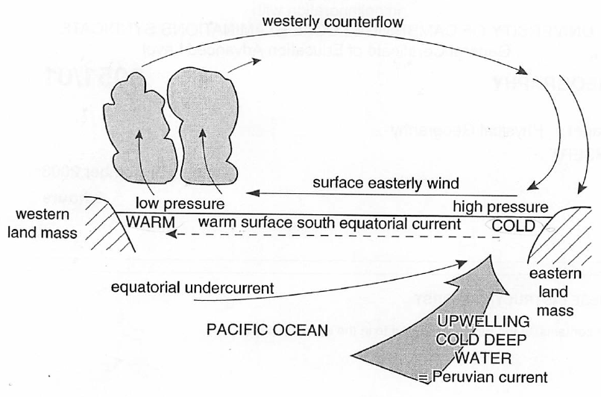

Resource 4 for Question 2

El Niño phase of the El Niño Southern Oscillation (ENSO) along the equatorial Pacific Ocean

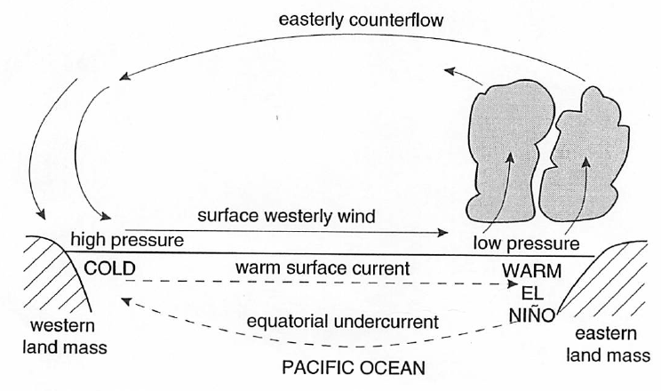
Resource 5 for Question 2

A section of a fluvial landform

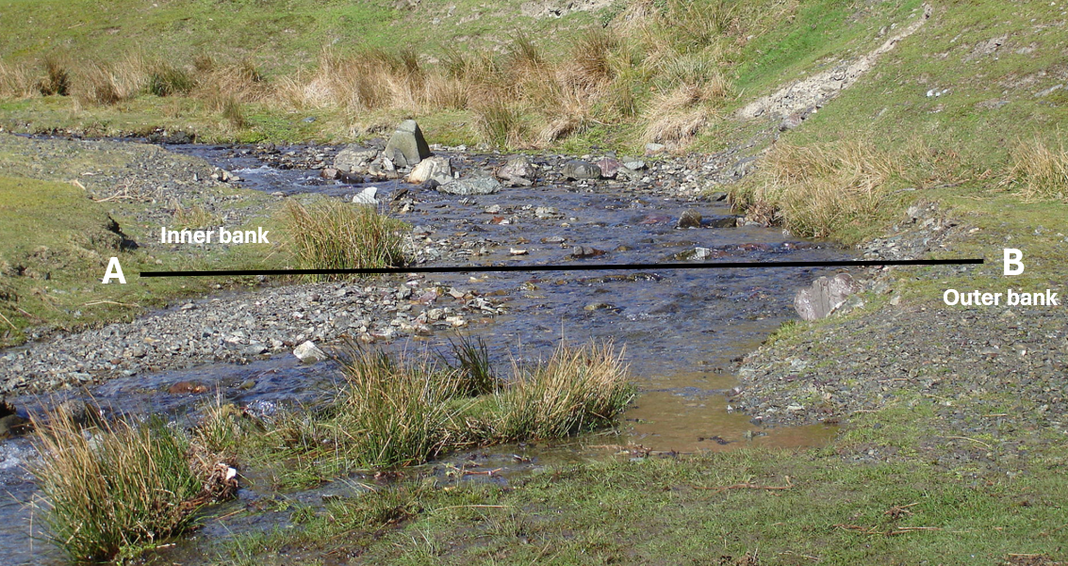
[Turn over

Resource 6 for Question 2

Climograph of a tropical desert

